**Project charter**

**Official project name** : Guider IT .

**Project sponsor** : Telecommunications Company.

**Project manager** : Alaa-eldeen Amin.

**Project Team**: Alaa-Eldeen Amin , Omar Ahmed Omar , Omar Mahmoud Abd Elsalam, Fady Refaat Ragheb, Ghada Fares Abdulla,Ghada Ragab Ali.

**Business case**

Purpose of the project : to make it easier for people to find the facilities and services by showing and guiding them to their destination. Guider app aims to give help to users every place they would go . It will be majorly depends global position system (GPS). Where ever the user be the second he will open Guider the app will automatically show him the facilities and services he may need ,it will show him nearest hospital ,gas station, restaurant , car workshop and every place he may need ,it will also display the hot number hot this places and distance between him and shown place .

**Key deliverables**

Guider mobile application that will work on both android and IOS .

**Project milestone**

1-Requirements review : Requirements specifications are complete, correct, approved and suitable. By 20/11/2021

2-Critical design review: Detailed designs fully implement the system architecture, are approved and are suitable for input into the development of code. By 10/12/2021

3-System test review : The software product has passed system testing and is suitable for input into acceptance testing.by 20/12/2021

4-20/1/2022 Initial deployment of a pilot set of 100 project-guider, testing, documentation, and problem solving. Republish a pilot set of 100 users, project guider 15/2/2022, to see if the project has any problems.

5-Product operational: The software is in use in its target operational environment.by 10/3/2022.

**Project resources**

* Staff : four android and mobile developers ,one graphic designer , one cyber security specialist and IT .
* Hardware : 3 laptops and a server .
* Software : Software licenses

**Budget**

Budget allocated for this project is 280000 $.

**Constraints :**

1- The project must achieve a working condition, meaning defining the purpose of implementing the project in addition to prior agreement on the benefits that will result from it and the possibility of achieving them, and in the event that this is not possible, the idea of ​​implementing the project should be canceled

2- this project must be delivered within the specified budget .

3- This project must be delivered on 15/3/2022 .

4- Any laptops or computers needed must be bought from lenovo company .

**Assumptions**

*You will arrive on time .

* The application will make it easier for you to know the location and ease of navigation .

* You will get all the required resources.

* All important stakeholders will attend the scheduled meetings.

**High level risks**

1-Sole reliance on this application can cause problems if you suffer a signal failure.

2-Technology is a poor match to some customers.

3-Local knowledge counts for a lot when traveling.

Relying solely on this application technology means that you can miss out on information that might be useful for your journey.

4-Inaccuracy : this application relies on receiving signals from at least four satellites. If they only call three, the positioning is not entirely accurate. Problems can occur when obstructions, such as walls, buildings, skyscrapers, and trees, obstruct the signal.

5- Battery failure : you are using a battery-operated device that runs out of power.

**Guider Information System (Scope &WBS)**

**Scope :**

* **Product scoop description**

Guider application will help everybody everywhere by guiding user to his destination . User receive a unique service which will be the first of it’s type . Anywhere the user will be he easily can find any place he want to go . Once the user open Guider he will be shown all facilities and services he might want . Guider will show the nearest hospital , restaurant , gas station , cars work-station , supermarket , police station , and any other place . User can also search a specific place and Guider will show him place’s hot number and the distance between him and this place . Guider will have a special service for urgent cases , which will need a protocol with the Ministry Of Health , user can call press a special button , we will include it to the user interface , and a nearest ambulance will be sent to him if he had an accident .

* **Product acceptance criteria**:

1- The application must be easy to use.

2- The user should get the information he wants from the application (Guider) easily.

3- The information must be correct and conform to reality.

4- The user is connected to the Internet to make the application easier for them to use.

5- The application should be light and not take up much .

* **Project Deliverables** :

There are temporary deliverables: they are deliverables that have not been completed or accepted by the customer. These deliverables help keep the customer informed and make suggestions if the matter does not go well.

* There are final deliverables: they are the final results submitted to the project according to the specifications of the user (client), as they are tested by the company’s monitoring team.

- As there are fixed stages, which are the initiation stage, the planning stage, and the implementation stage. The implementation phase includes. In each of these stages, different outputs will be required. For example: In the initiation stage, the output can be all the proposed projects.; In the planning stage: the output can be a report in which we define the entire project and make proposals for the initial budget and the tools used.; Then the implementation stage: the practical application and project experience, a program whose goal is to help everyone everywhere by guiding the user to his destination, which is the Guider application

* **Project exclusions** :

1-payment by application.

2- Directing the user to the site he wants to access.

3- The limits of the application must be within the user's home city and not in their neighbors, so that it is not difficult for the user to use the application.

4-The lack of Internet makes it difficult for the user in the application to get to where they want to go.

* **Project constraints**:

1-The predetermined budget of this project 20000$, and we have to complete the project under this budget.

2-Time: when starting a project, there will be deadlines that will be proposed by the project sponsor, and this project will end at least in 5 months.

3-Customer satisfaction is a key factor for a sustainable and long-running business in the market. All companies do business for their customers in the end. Because, they are the source of money and if you cannot satisfy your customers, you will not be able to stand against competition during time. Therefore, customer satisfaction is a crucial project constraint.

4-If the project scope extends due to scope creep like a project’s features, requests, and requirements, you may not have the time or resources to deliver the promised quality.

5-Technology Required: Every project requires the best technology or features to gain an advantage among competitors.

* **Project Assumption** :

1-Get best resources we need as we can as the budget

2-Setup software that can be compatibility with the hardware

3-Use the newest materials in the project to keep it use for longtime as we can

4-There must be plan b if project fails to make the loss less to turn it into a gain after sometime

5-If the project success, it will be the step for more and more success and we shouldn’t stop at this success.

*****************************************

*****************************************

**WBS :**

11.1 Initial planning for takes.

11.1.1 Assign tasks for teams .

11.1.2 Schedule task duration.

11.1.3 Gathering information about project App.

11.2 Development.

11.2.1 Database.

11.2.1.1 Table.

11.2.1.2 Relationship.

11.2.1.3 Data Entry.

11.2.2 Design.

11.2.2.1 Photoshop.

11.2.3 Creating App.

11.2.3.1 Android App.

11.2.3.2 IOS App.

11.2.4 Security App.

11.3 Testing.

11.3.1 Test Database.

11.3.2 Test App.

11.3.2.1 Test Android.

11.3.2.2 Test IOS.

11.4 Release Version..

11.5 Advertisement.

**\*\*\*\*\*\*\*WBS Dictionary\*\*\*\*\*\*\*\***

|  |  |  |  |  |  |  |
| --- | --- | --- | --- | --- | --- | --- |
| Work Package Name | Code Of  Accounts | Description  Of the element | Responsible  Person | Resources | Criteria for  Acceptance | Milestone |
| Assign tasks for teams | 11.1.1 | Planning the App | App  Programmer | Programmer | Used for Planning | 1 Week |
| Schedule task duration | 11.1.2 | Planning the App | App Programmer | Computer, IOS Programmer | Used to illustrate planning | 1 Week |
| Gathering Information about project App | 11.1.3 | Planning the App | App  Programmer | IOS Programmer | Used for  Date collection | 2 Weeks |
| Table | 11.2.1.1 | Development  Of Database | App  Developer | Computer,  App Developer | App was easy to use | 1 Weeks |
| Relationship | 11.2.1.2 | Development Of Database | App  Developer | Computer,  App Developer | Used to illustrate | 1 Week |
| Data entry | 11.2.1.3 | Development Of Database | App  Developer | Computer,  App Developer | Used to show Data | 1 Week |
| Photoshop | 11.2.2.1 | Type Of Design | App  Designer | Android ,IOS  Programmer | If app was easy to use | 1 Month |
| Android App | 11.2.3.1 | Type Of App Version | Android  Programmer | Computer,  Android Programmer | It used for android | 1 Weeks |
| IOS App | 11.2.3.2 | Type Of App Version | IOS  Programmer | Computer,  IOS Programmer | It used for IOS | 1 Week |
| Security App | 11.2.4 | Development  The App | App  Developer | App Developer | It used to data protection | 3 Weeks |
| Test Database | 11.3.1 | Testing the App | Tester | Computer,  Programmer | If app was  Efficient | 2Weeks |
| Test Android | 11.3.2.1 | Testing App Version | Tester | Tester | If app was  Efficient | 1 Week |
| Test IOS | 11.3.2.2 | Testing App Version | Tester | Tester | If app was  Efficient | 1 Week |
|  |  |  |  |  |  |  |
|  |  |  |  |  |  |  |
| Release Version | 11.4 | Stage Of App  Configuration | App  Releaser | Computer,  IOS,  Programmer | Used to illustrate | 3 Weeks |
| Advertisement | 11.5 | Stage Of App  Configuration | App  Advertiser | App Developer,  Programmer | Used to increase app  request | 1 Week |

* Responsibility matrix

|  |  |  |  |  |  |  |
| --- | --- | --- | --- | --- | --- | --- |
|  | Project manager | Tester | Designer | Developer | Network engineering | marketers |
| Create database | **A** |  |  | **R** | **A** |  |
| Create network | **C** |  |  | **A** | **R** |  |
| Create website | **C** |  |  | **R** | **A** |  |
| Create design(UX/UI) |  |  | **R** |  | **A** |  |
| Create security |  |  |  | **A** |  |  |
| Test security |  | **R** |  |  | **C** |  |
| Test website |  | **R** |  | **A** |  |  |
| Marketing | **S** |  |  |  |  | **R** |

**R=Responsible A=Approval**

**C=Consult S=Support**

**Network**

|  |  |  |  |
| --- | --- | --- | --- |
| Activity | Description | Preceding Activity | Activity Time by week |
|  |  |  |
| A | Planning | None | 4 |
| B | Database | A | 3 |
| C | Design | A | 4 |
| D | Application | C | 2 |
| E | Security | D | 3 |
| F | Testing | E | 4 |
| G | Release version | F | 3 |
| H | Advertisement | G | 1 |
|  |  |  |
|  |  |  |  |
|  |  |  |  |
|  |  |  |  |
|  |  |  |  |

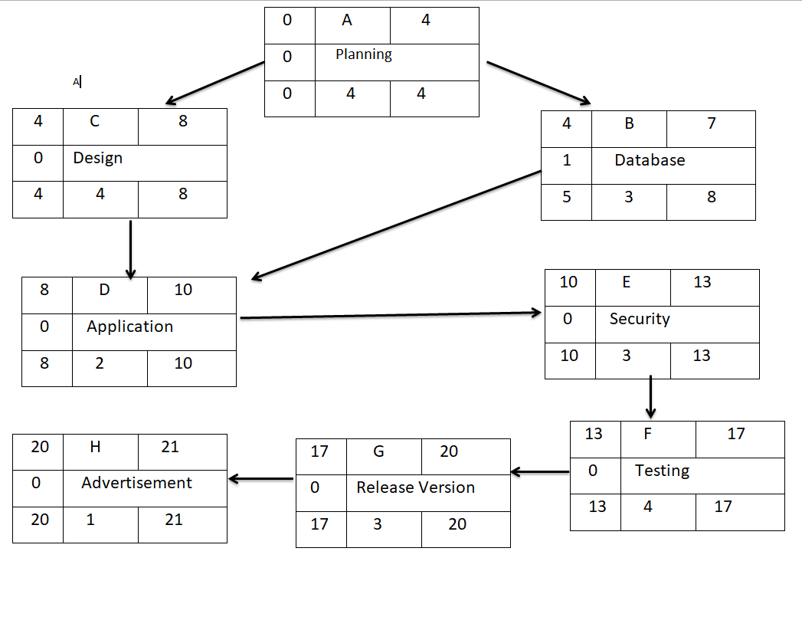**Critical path : A-C-D-E-F-G-H**

**Resources**

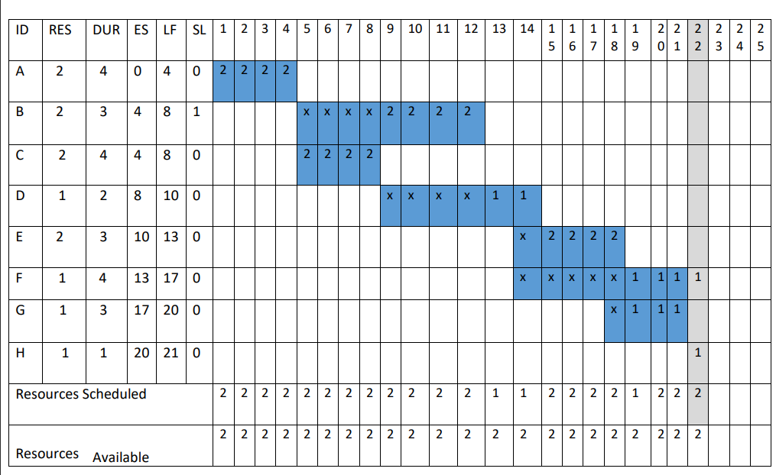

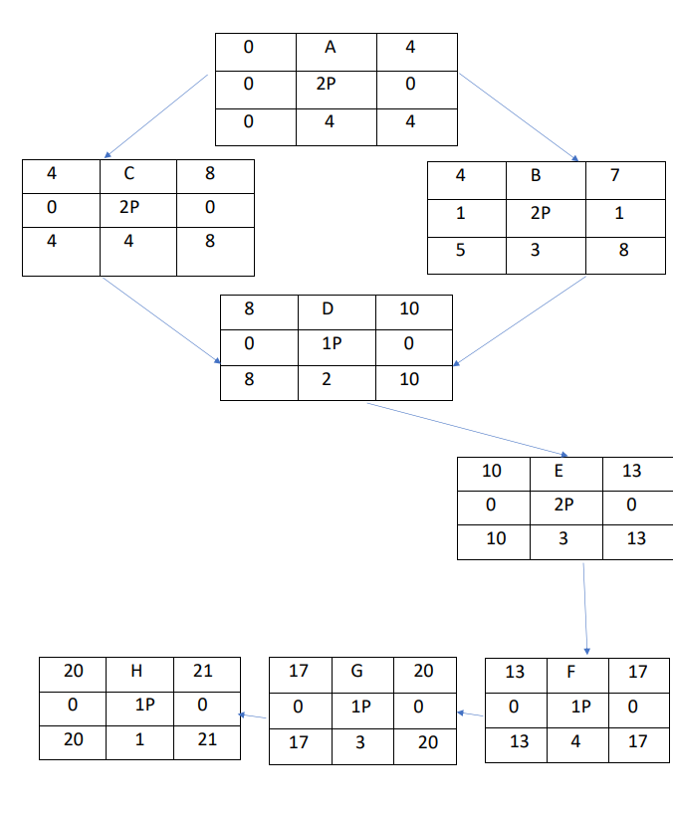

Budget :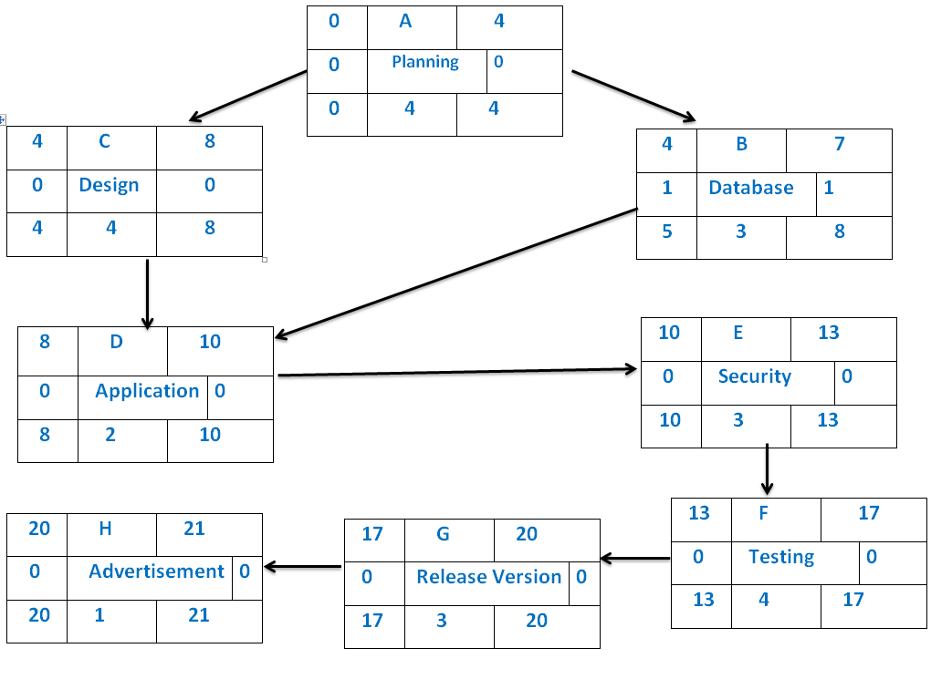

* 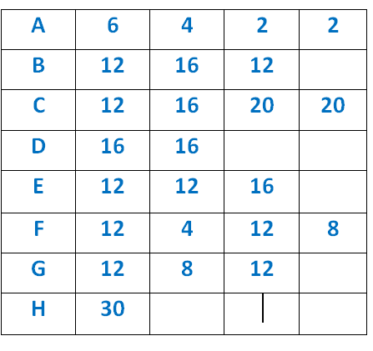cost by week :

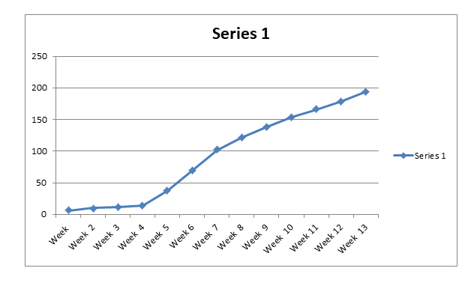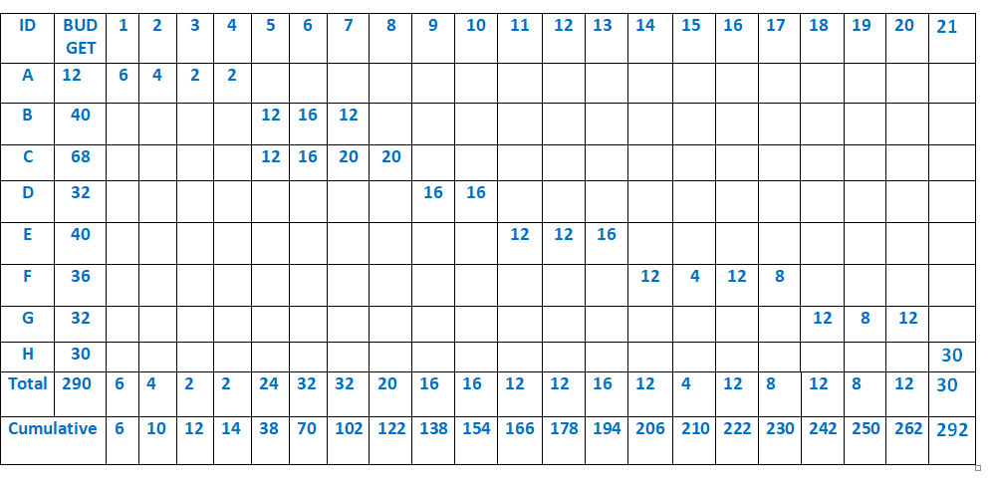

Risk Management

1. **What are the risks that can face your project?**

* **Sole reliance on this application can cause problems if you suffer a signal**

**failure.**

* **Technology is a poor match to some customers.**
* **Local knowledge counts for a lot when traveling.**

**Relying solely on this application technology means that you can miss out**

**on information that might be useful for your journey.**

* **inaccuracy: this application relies on receiving signals from at least four**

**satellites. If they only call three, the positioning is not entirely accurate.**

**Problems can occur when obstructions, such as walls, buildings,**

**skyscrapers, and trees, obstruct the signal.**

* **Battery failure: you are using a battery-operated device that runs out of**

**power.**

1. **How to deal with these risks?**

* Providing the advantage of using the application without the Internet.
* Constantly issuing the necessary updates to solve technical problems.
* Writing usage instructions for the user first opening the application.
* Easy way to view the world in the app to make it easier to save to avoid the risk of battery running out.

1. **Demonstrate how to monitor your project?**

* By making a questionnaire for users’ opinions about the application and issuing the necessary updates for the smoothness of the application, treating all problems and preventing any gaps in the application.

******************************************************

* By :
* Alaa-Eldeen Amin
* Ghada Ragab Ali
* Fady Refaat Ragheb,
* Omar Ahmed Omar
* Ghada Fares Abdulla
* Omar Mahmoud Abd Elsalam